Genpact Due Clearance: -

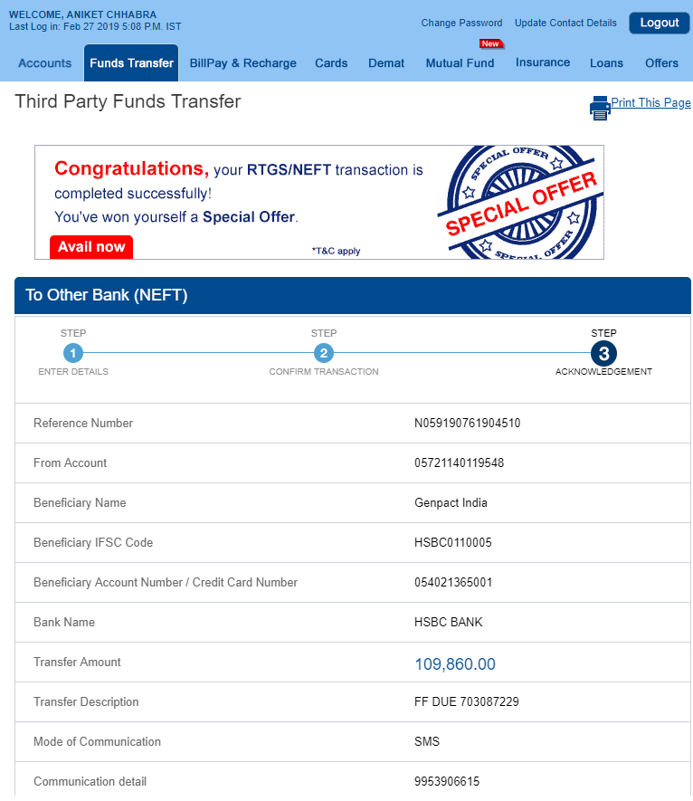

Mirae Asset Fund – Genpact_13r

Invesco login – aniketchhabra.1987@gmail.com

Invesco Fund – Fidelity_13r

HDFC user_id – aniket_chhabra

HDFC Fund - Genpact_13r

110162775760 – PRAN

Password – Qwer_13r

**55288496 - PYPL**

Etrade Userid – 39462747

Password – Qwer@13r

Citibank User ID - ANIKET116

Password – Qwerty@13r

Marriott email id – [aniketchhabra.1987@gmail.com](mailto:aniketchhabra.1987@gmail.com)

Password – Qwer@13r

Amex card login - aniket13r

Password –

Bank of Baroda – neha Sinha loan account

Application password – 0502

Mpin = 1939

ICICI Lombard insurance portal

Username – [anchhabra@paypal.com](mailto:anchhabra@paypal.com)

Password – Qwerty_13r

**Ineuron.ai**

Username – email id

Password – Qwerty_13r

Git_hub password – Fidelity_13r

git_token_13121987

Icici Bank – 544457408

Password – Asdfgh_13r

**GCP Password –**

Bnmyui_13r

Sodexo card pin – 8663

**BOB password -**

Login password – 0202

Txn password – 0505

**KOTAK MF -**

Login – [ANIKETCHHABRA.1987@GMAIL.COM](mailto:ANIKETCHHABRA.1987@GMAIL.COM)

Password-Qwerty_13r

**Apple Id –**

ID - [Aniketchhabra.1987@gmail.com](mailto:Aniketchhabra.1987@gmail.com)

Password – Zenpact@1609

**Quant Fund –**

Login password – ARNPC5835D

Password – Qwer@13r

**State Bank of India –**

**userID – aniketchhabra13r**

profile_password – Araayaans@13r

newpassword – Aniketneha@13r

**EPFO/UAN –**

**UserId (UAN) –** 100083469010

**Password –** Paypal@13r

**TATA Mutual Fund –**

**Login Id –** ARNPC5835D

**Password –** Qwer@13r

**Nippon India Mutual Fund –**

**Login Id –** [aniketchhabra.1987@gmail.com](mailto:aniketchhabra.1987@gmail.com)

**Password –** Qwer_13r

**ICICI Mutual Fund –**

User_id – 9953906615

Password – Zenpact@13r

PayPal Exit email –

Take note to the Payroll/ F&F process for your guidance.

|  |  |
| --- | --- |
| 1 | * F&F Salary Payout by 30th if all Clearances updated in Exit Tool by 15th * If clearances come after 15th of the month, it would be paid by next pay-cycle |
| 2 | * Payment Includes -   + Salary till DOL, Unclaimed Flexi, Other Ad-hoc   + PTO Balance(Max 45days) and Gratuity (Eligible for total service more than 4 yrs and 6 months) * Recovery, as applicable (Joining Bonus, Other Bonus, Relocation Allowance, excess salary, etc.) |
| 3 | * ADP Portal Access credentials will be sent a week after F&F is paid. * Here the F&F Payslip and Income Tax Statement will be available. * Employee need to download all the Payslip and ITCS from ADP portal access within 90 days |
| 4 | * Form-16 will be available in ADP Portal by June/July, * Email notification will be sent to personal email id when Form-16 is made available. |
| 5 | PF Transfer Support & Flexi Claims/Investment Proofs to be sent to [india-payroll@paypal.com](mailto:india-payroll@paypal.com)  ESPP, RSU/PSU related, please write to Global Stock Plan Services [stock@paypal.com](mailto:stock@paypal.com) |
| 6 | For Queries ADP - Contact ADP Service Center UIFN: 18002585920; Outside India : [+91 406150 5920](tel:+914061505920) Hours: 8.30 a.m. - 5.30 p.m. IST **PayPal PoC:-**[india-payroll@paypal.com](https://nam11.safelinks.protection.outlook.com/?url=http%3A%2F%2Findia-payroll%40paypal.com%2F&data=05%7C01%7Canchhabra%40paypal.com%7C6a88e3f9191f4bf0582908dbdc1d4514%7Cfb00791460204374977e21bac5f3f4c8%7C0%7C0%7C638345790497148115%7CUnknown%7CTWFpbGZsb3d8eyJWIjoiMC4wLjAwMDAiLCJQIjoiV2luMzIiLCJBTiI6Ik1haWwiLCJXVCI6Mn0%3D%7C3000%7C%7C%7C&sdata=%2FQyzsDvap%2BRppuiYmP4mpVexlj8Nz26qNsNGvuGdNXg%3D&reserved=0) |

For other requests or clarification please feel free to contact us by raising a HR ticket to [**Employee Central**](https://paypal.sharepoint.com/sites/HRHub/SitePages/HRcontactus.aspx) team.

To view the status of No-due clearance provided by different departments [Click here](https://nam11.safelinks.protection.outlook.com/?url=https%3A%2F%2Fapps.powerapps.com%2Fplay%2Fe%2F31bf5fc6-42f9-e537-8819-4998604d5705%2Fa%2F18006eb1-2a71-4bcf-9329-b8f3aaa695ff%3FtenantId%3Dfb007914-6020-4374-977e-21bac5f3f4c8%26source%3Dportal&data=05%7C01%7Canchhabra%40paypal.com%7C6a88e3f9191f4bf0582908dbdc1d4514%7Cfb00791460204374977e21bac5f3f4c8%7C0%7C0%7C638345790497305001%7CUnknown%7CTWFpbGZsb3d8eyJWIjoiMC4wLjAwMDAiLCJQIjoiV2luMzIiLCJBTiI6Ik1haWwiLCJXVCI6Mn0%3D%7C3000%7C%7C%7C&sdata=hH576PWqxk5uE4VgAjngF56UFN0FH9FtuRDj57wrmDA%3D&reserved=0)

**For post-exit support, please send an email to**[**DL-PP-EmployeeCentralCases@paypal.com**](mailto:DL-PP-EmployeeCentralCases@paypal.com)

On behalf of the company, we thank you for your valuable contributions and we wish you all the best in your future endeavors.

***Please do not reply to this auto-generated mail.***

Regards,  
Employee Central